Classroom Floor Plan: | Description of the Classroom (e.g., age, grade level, type of classroom, student ‘types’):
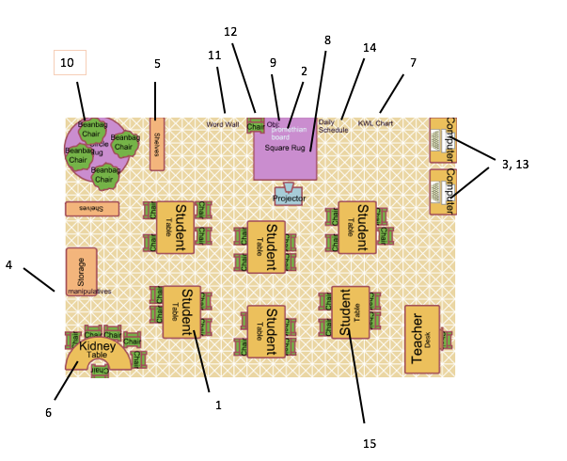 | This classroom consists of 24 third graders. It is a student-centered classroom that gives students choices on how they complete their assignments and where they sit. Technology is integrated within the classroom and collaboration between students is emphasized. This is an inclusive classroom as there are students with learning disabilities such as dyslexia and ADHD. Four out of the 24 students have a learning disability and three students are identified as GT. One student is an ELL.

Learning Environment Design Guide Template

Click on UDL Principles and Checkpoints for additional information!

III. Provide Multiple Means for Engagement:

1. Provide options for self-regulation
Number | Discuss how the option/example aligns with the guideline.
10 | In order to support activities that encourage self-reflection and identification of personal goals, there is a quiet reading area that students can use. In students’ checklists that focus on their goals, I want them to use the quiet area as a place they can use if they are on the verge of an aggressive outburst or if they are having trouble staying on task. Reading can be a great coping skill for students and I want that area to be a “safe space” for students for them to regulate themselves.

2. Provide options for sustaining effort and persistence
Number | Discuss how the option/example aligns with the guideline.
6 | At the kidney table, there will be learning groups that will be fixed rather than flexible. This will allow students to work with peers effectively and they will get the support they need on a specific skill. This space be used for teacher instructed activities such as guided reading, and it will also be an area where students can get feedback on their work. Students can also use the kidney table when the teacher is not using it to interact with each other with activities such as peer tutoring and partner reading. By having this space, there is an emphasis on collaboration and communication in the classroom, as well as mastery-oriented feedback, which supports students staying engaged throughout lesson instruction.
15 | Having student tables instead of desks supports and provides opportunities for students to work with each other. It creates a community of learners as they will be encouraged to help each other if they are confused, which helps them stay persistent while working. Also, when the teacher assigns projects and group work, tables provide a smooth transition into collaboration. At their tables, each student would have a job and they would switch around throughout the quarter. There could be a floor cleaner, paper person, collector, and a material monitor. This gives every student a role or responsibility, which fosters collaboration and communication to keep students involved in the classroom.

3. Provide options for recruiting interest
Number | Discuss how the option/example aligns with the guideline.
1 | In order to recruit interest, it is important to optimize individual choice and autonomy. To do this, students are able to pick their own seats every quarter. They will be encouraged to pick a seat that they will do their best work in. This allows them to sit next to people they feel they can learn best around and allows them to be more comfortable. For example, a student with dyslexia or ADHD may stay engaged for longer if they are towards the front of the room rather than the back. By letting students pick it every quarter, it also provides stability in the classroom as students are not changing their seats constantly. This provides independent choice, but also emphasizes engagement.
5 | The books in the bookshelves will be age and ability appropriate for my students. I will be providing books that are on the 2nd grade level, but also some that are above and below grade level. This allows all abilities to be present within my library. I will also provide books that represent multiple racial, cultural, ethnic, and gender groups so that students feel that they can connect their lives to the books I have. Students are more engaged with books that are relevant to their lives, which is why the books on my shelves in the classroom need to be thought about.
14 | The daily schedule is in the front of the classroom to keep students engaged throughout the day. By having this schedule, students are prepared for what is next and when the transitions will be. When students do not know what to expect, they will focus on asking the teacher questions regarding what is coming up and will spend time focusing on that instead of the activity they are supposed to be engaged in. Giving students the expectations and the schedule for the day keeps students interested in content rather than wanting to know what the rest of the day entails.
I. Provide Multiple Means of Representation:

4. Provide options for comprehension
Number | Discuss how the option/example aligns with the guideline.
7 | The KWL chart for each new unit allows students to activate their background before the lessons begin. Each student will put a post it note in the K column to help them, and the teacher, identify what they already know. This activity allows teachers to know which students have very little background knowledge on the content as it can have a big impact on their comprehension. They will also put a note in the W section before the unit begins with questions about what they want to know in relation to the unit. While the lessons continue and students learn more information, they will record what they learned at the end of unit in L section. Students are able to highlight the big ideas of the content they learned and teachers can see if there is anything that needs to be explained further.

5. Provide options for language, mathematical expressions, and symbols
Number | Discuss how the option/example aligns with the guideline.
11 | The word wall in the front of the room will be used to clarify vocabulary and symbols. The word wall can be used in whichever subject deemed necessary. To make it most effective, the words will come from the curriculum and they will be pre-taught. Before the teacher gives the definitions to the students, the class will use their background knowledge to brainstorm what the word means and how it is applied in the content. The teacher will have students make chants or use actions that go along with the words to help with memorization, however, application will be heavily emphasized. The word wall will not only be used for words, but for subjects such as math, symbols will also be on the wall.

6. Provide options for perception
Number | Discuss how the option/example aligns with the guideline.
2 | The promethean board in the classroom allows the teacher to provide alternatives for auditory information. On the promethean board, the teacher can put the written transcription of the videos that are being played on the board with the video. Diagrams and charts can also be made by the teacher on the promethean board. This allows teachers to model to students what they are expected to do and can be used to organize information that is being gone over verbally. Since some students are auditory learners while others are visual learners, this helps address both styles.
3 | The computers on the side of the room allows teachers to customize the display of information for students. These would primarily be used when students are assigned a reading such as an article or a book. With these devices, students would be able to change the font, increase or decrease the size of the text, have the book the class is reading read aloud to them, pick how loud they want it read to them, and decide how fast or slow it is read. This would help students with dyslexia, the English Language Learner, and students who are below grade level in reading as they would have flexibility with how information is displayed to them.

II. Provide Multiple Means for Action and Expression:

7. Provide options for executive functions
Number | Discuss how the option/example aligns with the guideline.
9 | In order to guide appropriate goal-setting for students, it is important that there are objectives posted in the classroom. It is beneficial for the teacher to work with the students to form an objective for the day and for the unit overall. This helps them work on the skill of goal setting as it needs to be achievable. The objective will be posted in the front of the room where the promethean board is so that students can remind themselves of the goal they are working towards. At the beginning and end of the lessons, the objective will be visited to establish what is going to be learned, and then to determine if it was met.
12 | The chair on the front square rug will be used when students model a think aloud with a book. This is a reading comprehension strategy that the teacher can first show students, and then have them do it on their own. The student will introduce the book to the class and ask them questions such as why are we reading this book and how does it relate to what they are learning. As they are reading the book to the class, the student will go over what they are wondering while they are reading and re-read sentences where there is confusion with what the words are conveying. This strategy allows a student to practice the process they should go through while reading and it scaffolds students who are not able to do that skill on their own yet.

8. Provide options for expression and communication
Number | Discuss how the option/example aligns with the guideline.
4 | In the storage area, there will be bins of manipulatives for students to use. Examples of these manipulatives include base-ten blocks, 100s charts, counter chips, dice, and snap cubes. Having these materials allow students to express what they know in a way that is different than writing how they solved it. They can also be used when students are confused with how to solve a problem, as it provides a physical representation of how the answer is found. Manipulatives help students gain a deeper understanding of the skill as it is a hands on activity.
8 | The square rug in the front of the room allows the use of multiple media for communication. As I want my classroom to be student centered, students need to be given the choice on how they want to display a project or convey their knowledge to the class. This includes writing a paper, making a poster, doing a PowerPoint, making a play, writing a poem, creating an illustration, and more. In order for these to be presented to the class, there needs to be an area for students to do this, which will be the square rug. On the rug they will put on their play, go over their PowerPoint, show their drawing, and explain their assignment.
13 | The computers will also be used when students are composing a piece. Instead of writing, students will have the option to type their piece. Since there are only 2 computers in the classroom, the teacher will request the mobile laptops for the days that the students are working on their composition. This allows students to use spellcheck and grammar check when writing their piece. These programs can also be used for the ELL student and the student with dyslexia on a regular basis when they are doing written assignments.

9. Provide options for physical action
Number | Discuss how the option/example aligns with the guideline.

